Step 01 – Logged into AWS Console

Step 02 - Searched and navigated to VPC

Step 03 – Create VPC

Step 04 – create internet gateway

Step 05 – Attach an internet gateway to a VPC to enable the VPC to communicate with internet.

Step 06 – Create Private and Public Subnets

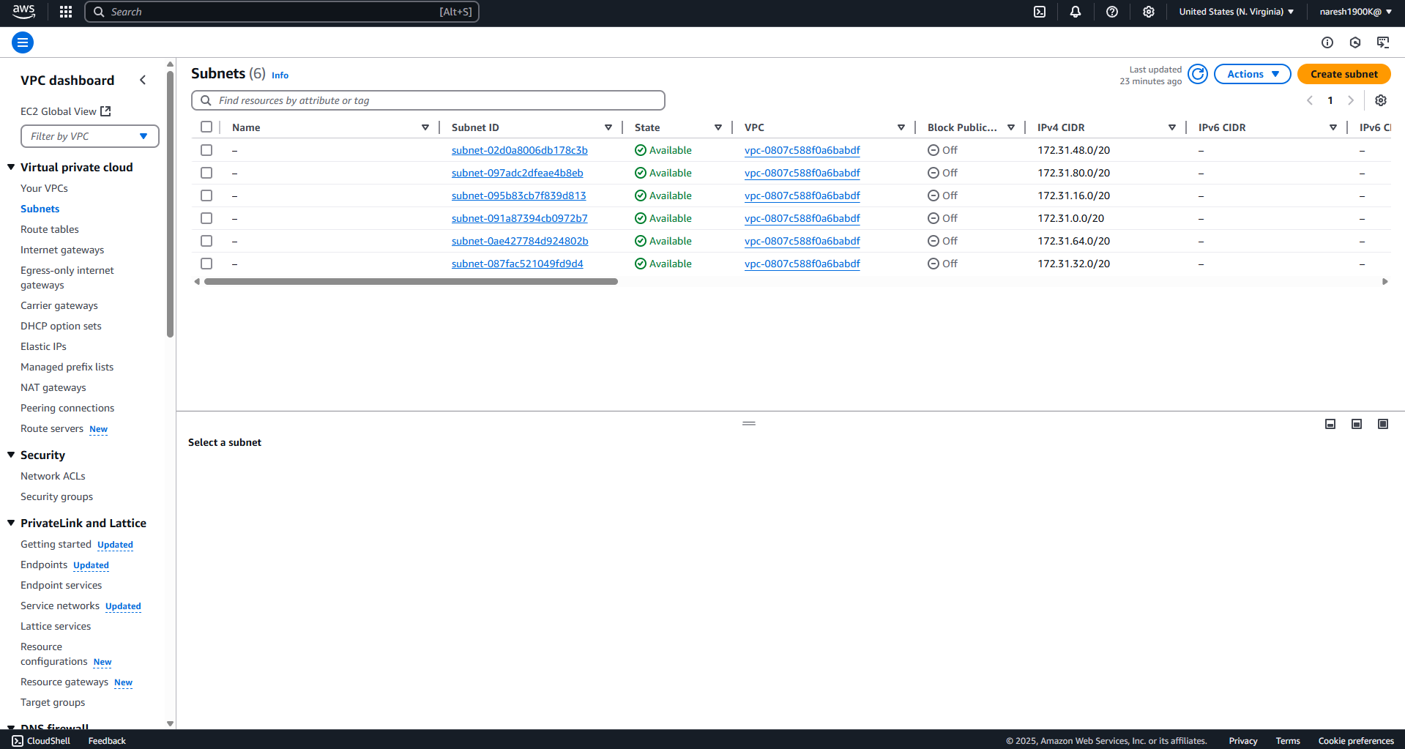

Public Subnet

Step 07 - Create Route Table for Public Subnet

Add the created internet gateway

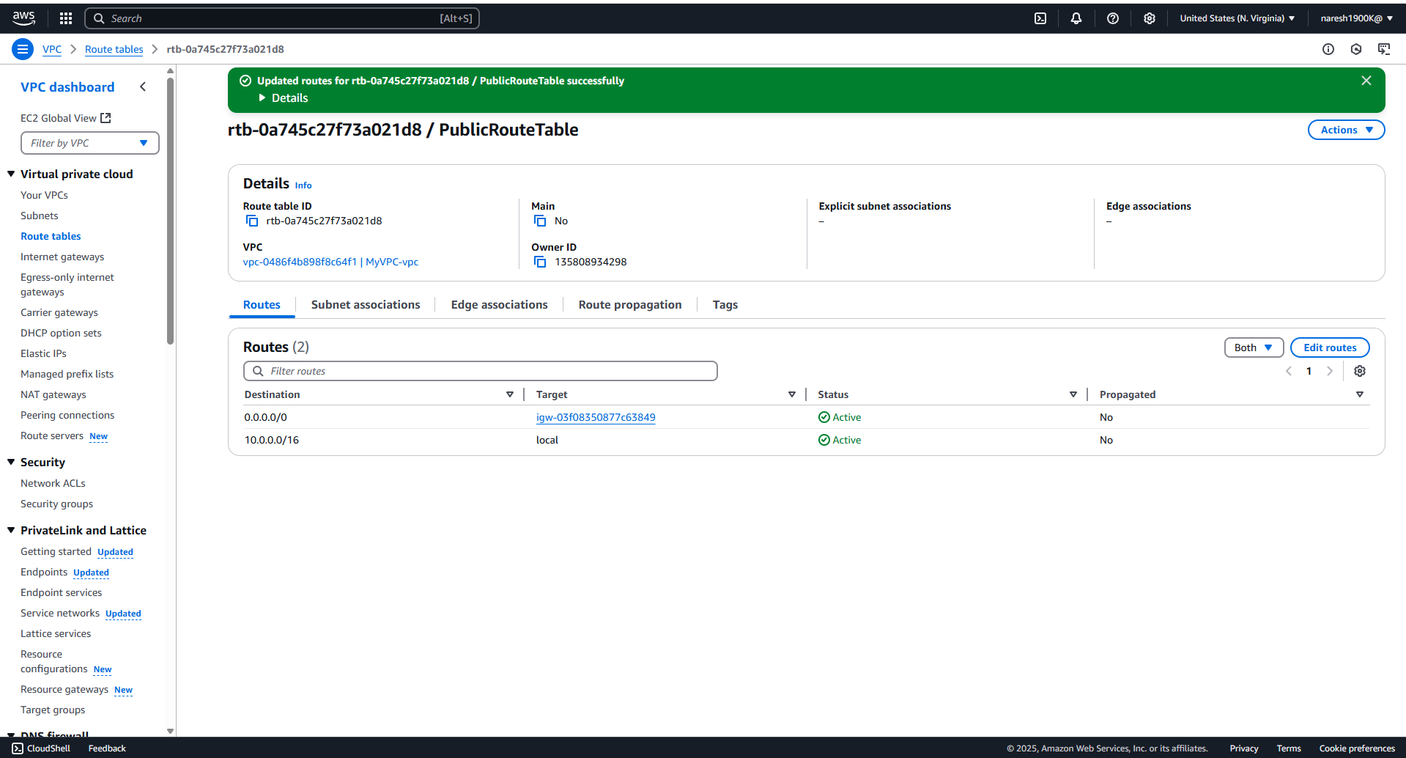

Step 08: Launch an EC2 Instance



